THE
MAGNOLIA

COLLECTION
INDIA POSTAL HISTORY AND STAMPS USED ABROAD

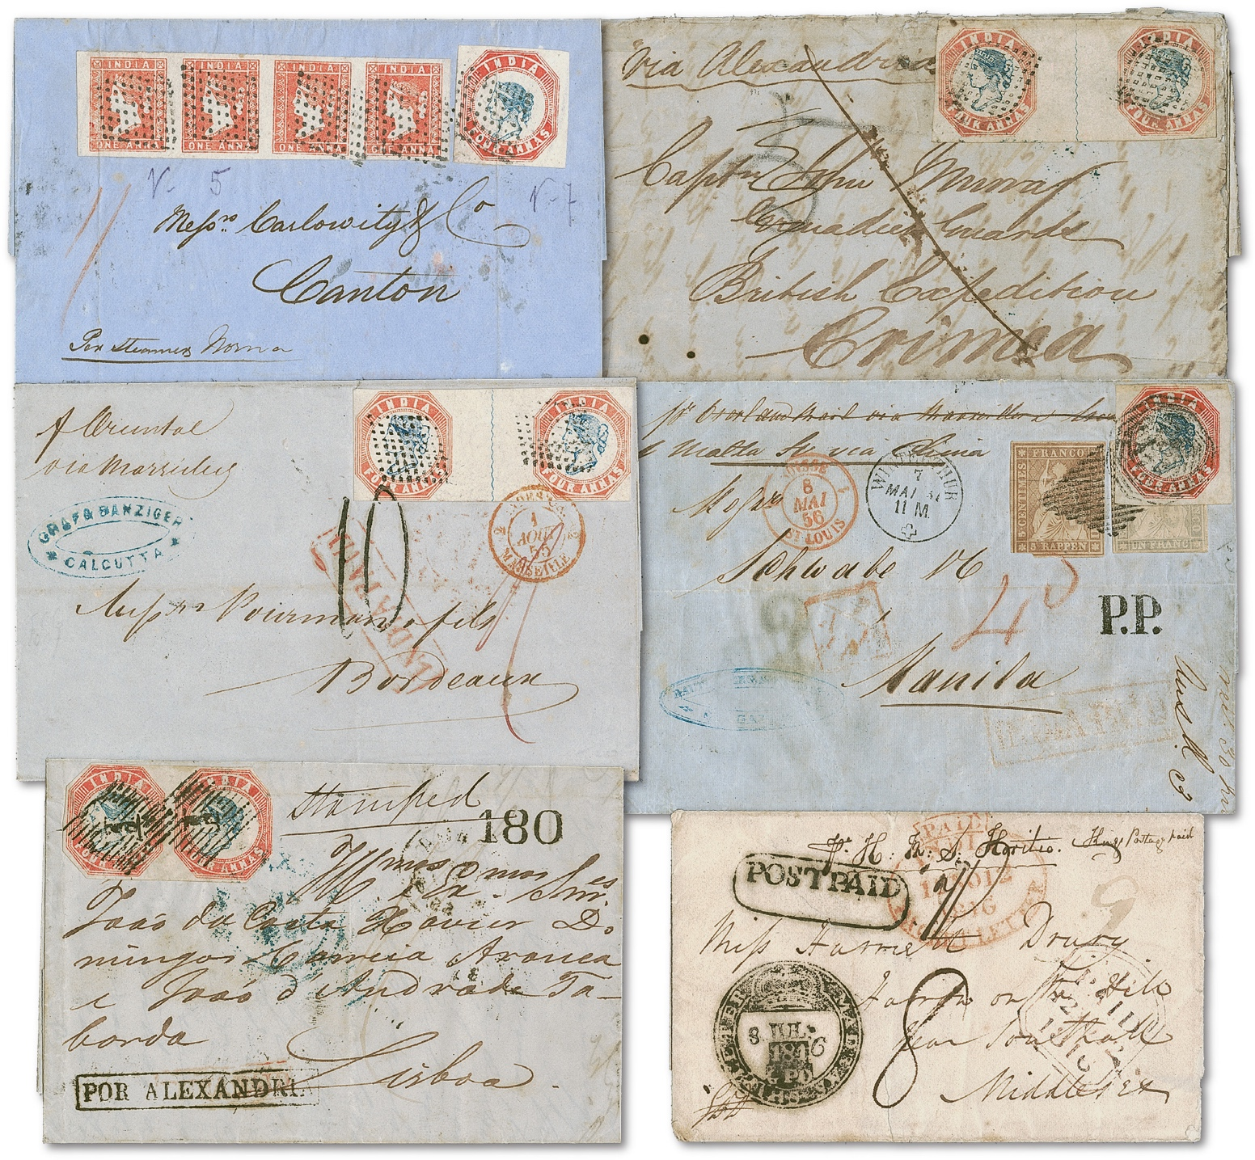



The Magnolia Collection of India Postal History and Stamps Used Abroad will bring to market a panoramic array of spectacular covers, spanning the long history of the postal system serving the Indian subcontinent and Asia. By order of the trustee, Siegel International will offer the collection in auctions starting in 2023.

