A week of Indian philately like no other...


THE
MAGNOLIA

COLLECTION

INDIA POSTAL HISTORY AND STAMPS USED ABROAD

By order of the trustee, Siegel International is honored to offer at unreserved auction this spectacular and comprehensive collection of India. The first in a series of sales will be held in New York City on Thursday, May 11, 2023.
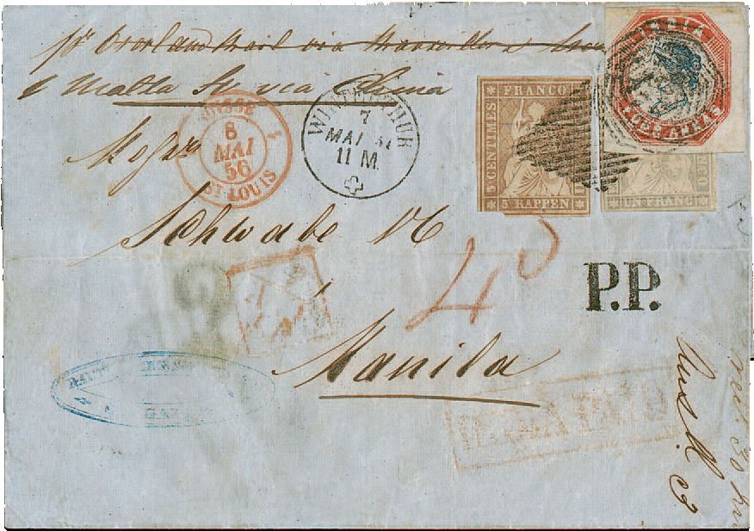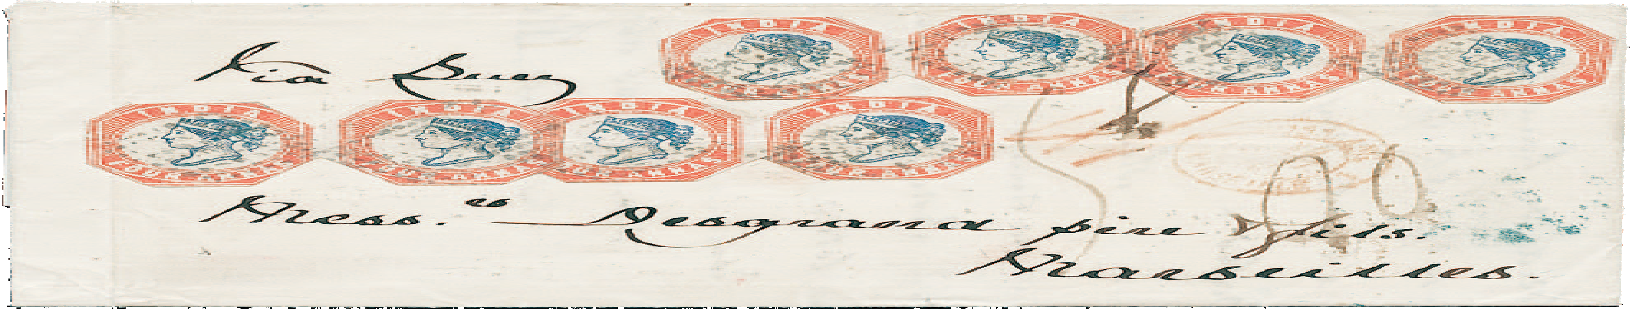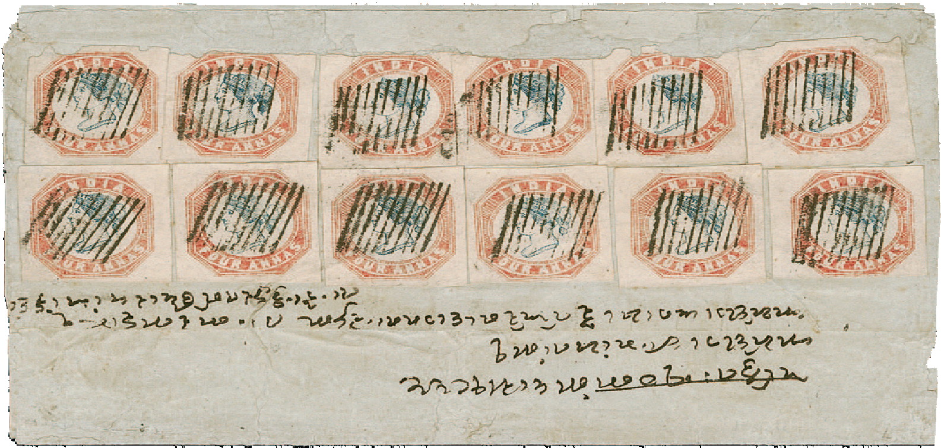
To celebrate the sale of this important collection, Siegel International has arranged a series of special events on the days leading up to the first sale. We invite collectors from around the world to participate in India week. This brochure provides details of the events and shows just a few of the wonderful items to be offered on May 11.

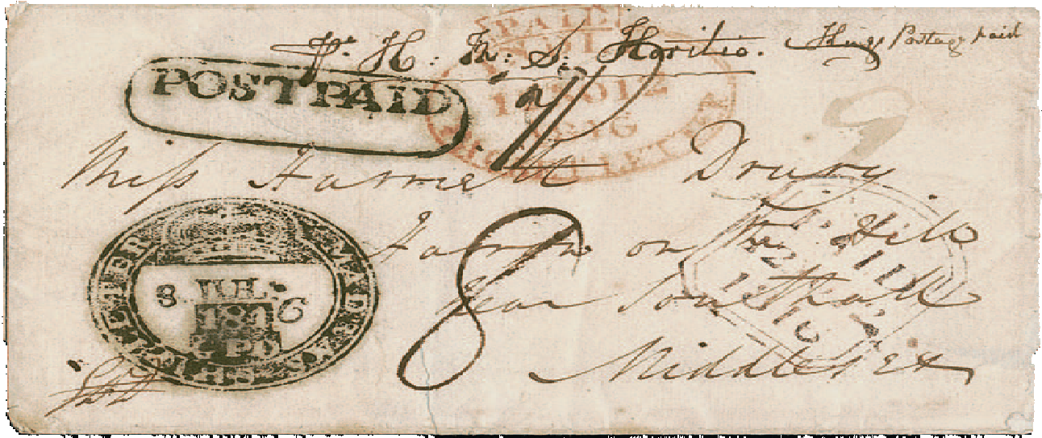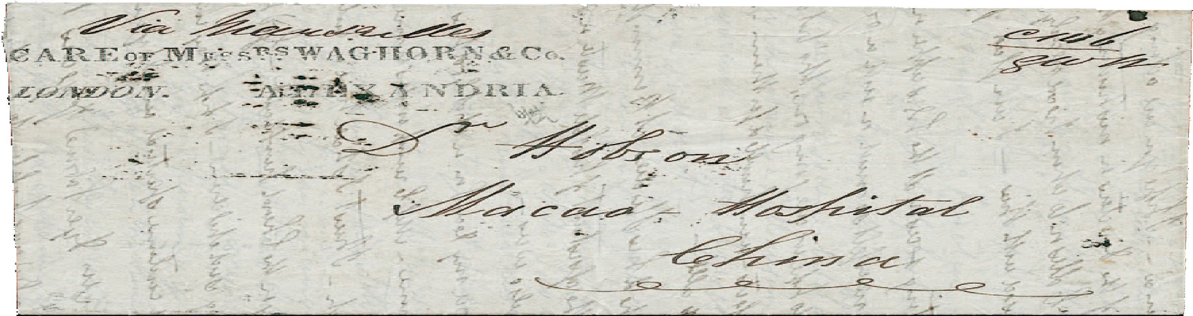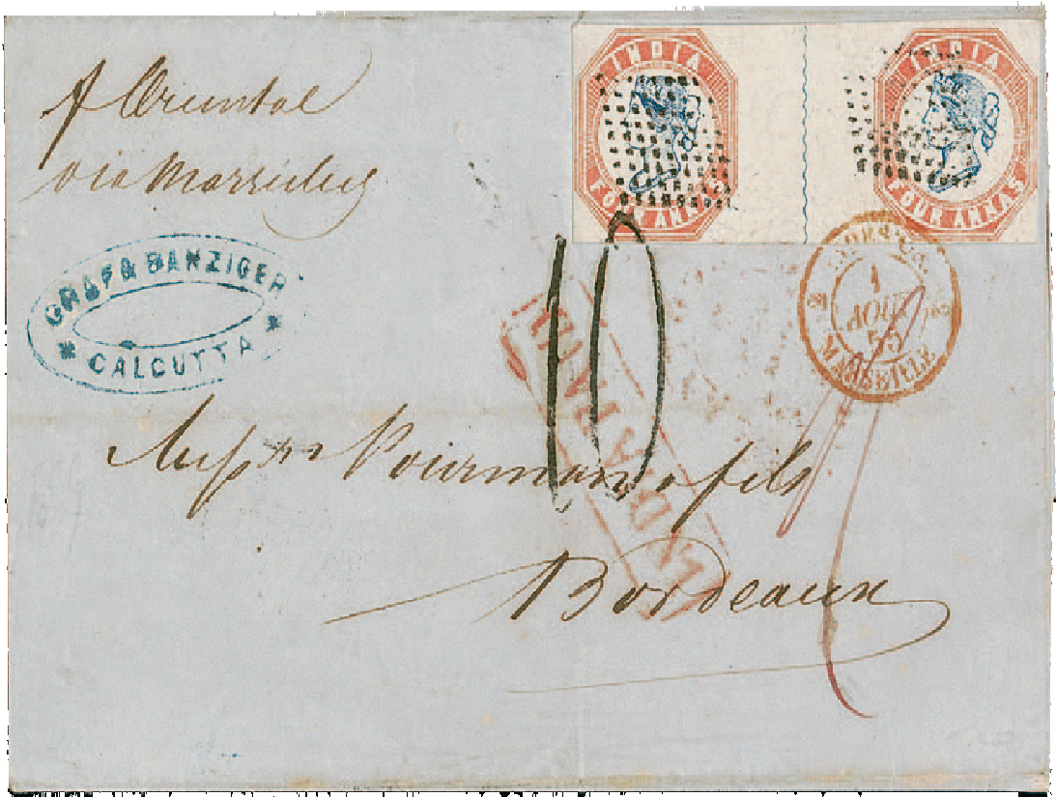Discover the fascinating postal history of India...
Please join us Monday, May 8, and Tuesday, May 9, in Washington, D.C., home of the Smithsonian Na- tional Postal Museum, the world’s largest and finest philatelic museum.

Monday, May 8 – 2:00 p.m. to 5:00 p.m.
VIP tour of the National Postal Museum, highlighted by a visit to the vaults of the museum, where you will discover amazing items the public rarely sees.

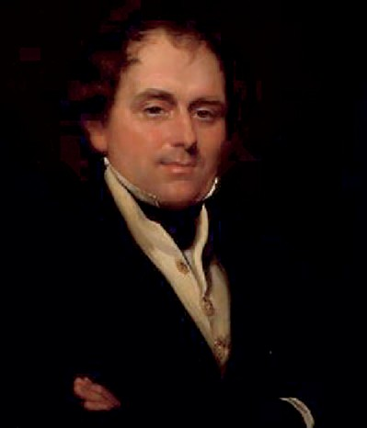
Thomas Waghorn Portrait by George Hayter, cira 1847

Monday, May 8 – 5:00 p.m. to 6:00 p.m.
Private cocktail reception at the National Postal Museum—there is limited availability, so please send your reservation request today to Andrew Titley at andrew@siegelauctions.com

Tuesday, May 9, 10:00 a.m. to 12:00 p.m.
Discover Indian Native States Hidden Treasures from the vaults of the National Postal Museum, presented by Daniel Piazza, Curator of Philately.
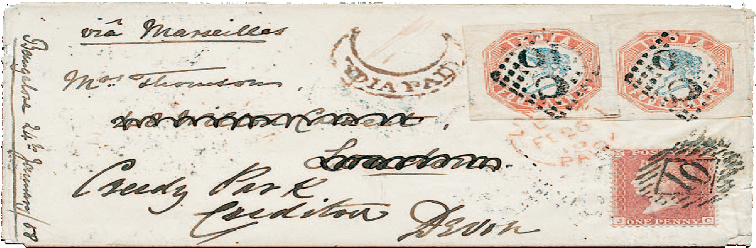Following the Hidden Treasures presentation, we will have the honor of hearing W. Danforth (Dan) Walker, RDP, FRPSL, give his informative commen- tary and observations about the museum holdings. Mr. Walker is a prominent philatelic judge and noted collector of Indian Native States.
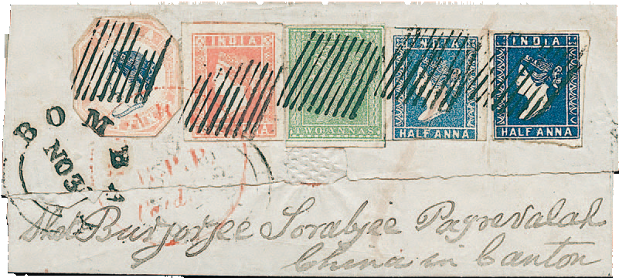

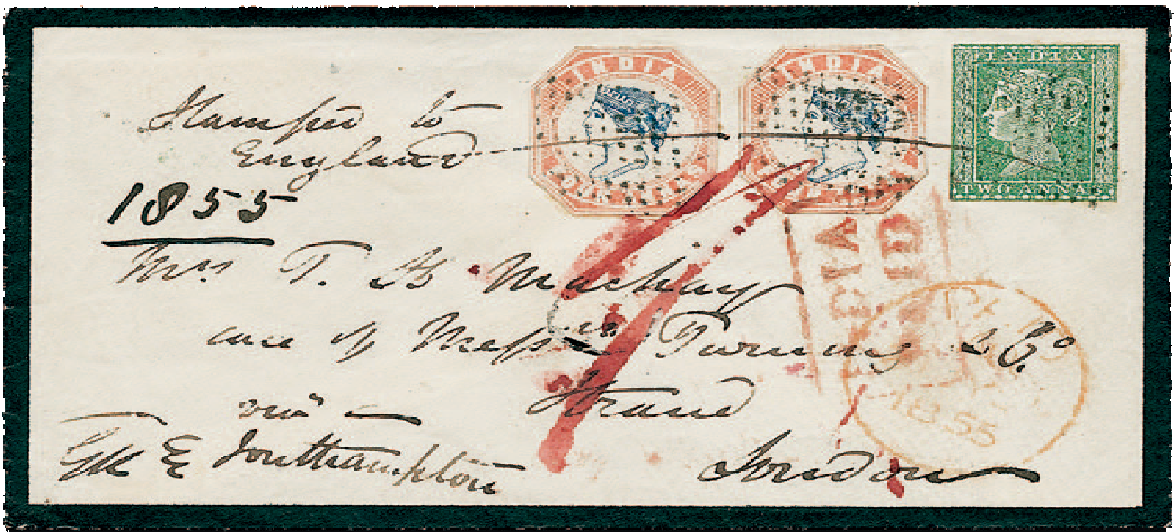Presale exhibition of Magnolia, Part 1
Concurrently with the special events at the National Postal Museum, all of the Magnolia Part I auction lots will be available for viewing at the Kimpton Hotel George (Presidential Suite), just steps away from the museum itself, at 15 E St. NW. Viewing times will be 10 a.m. to 4 p.m, Monday, May 8, and Tuesday, May 9.

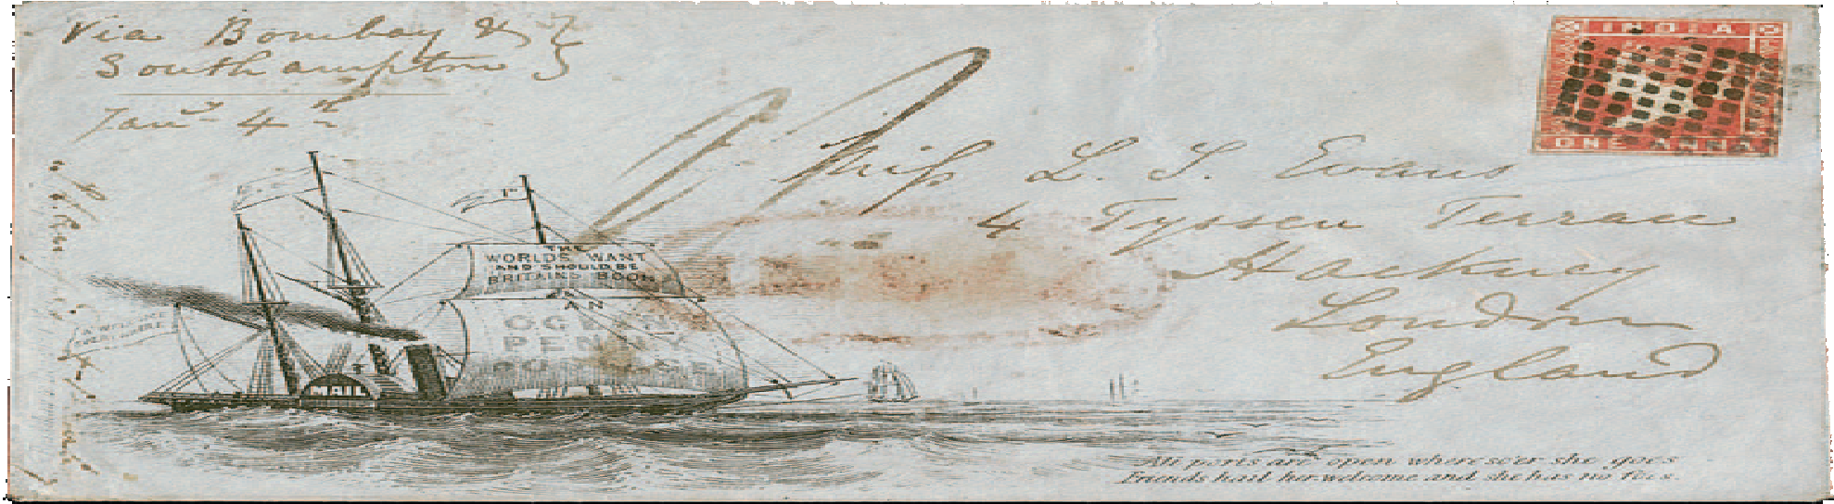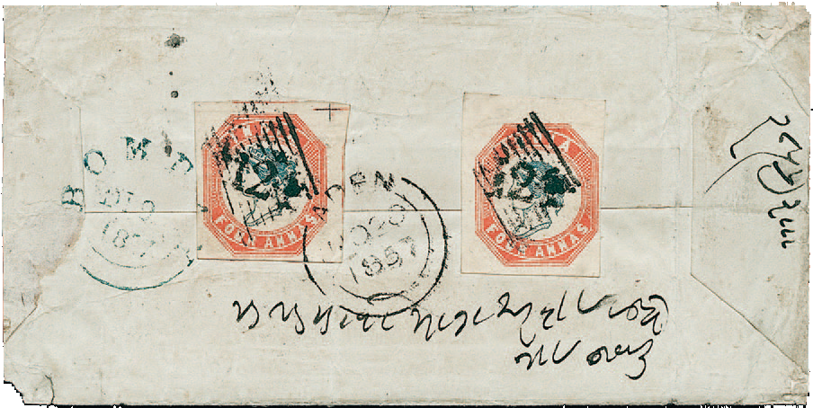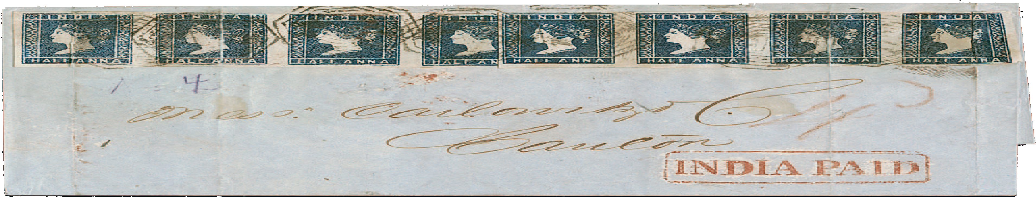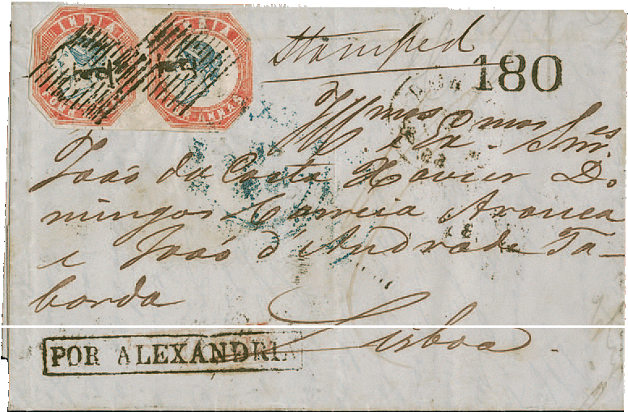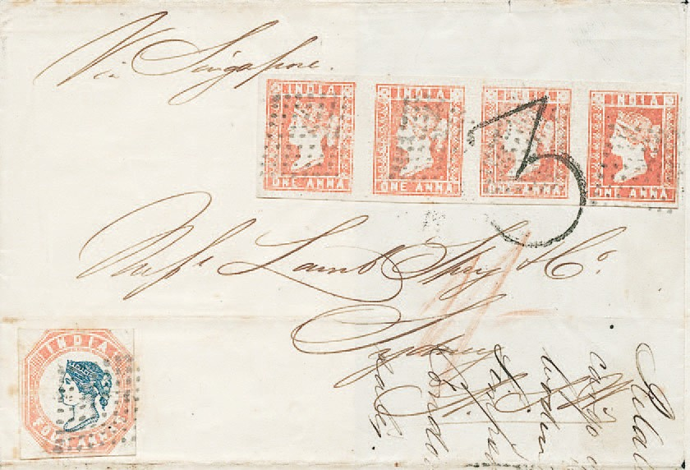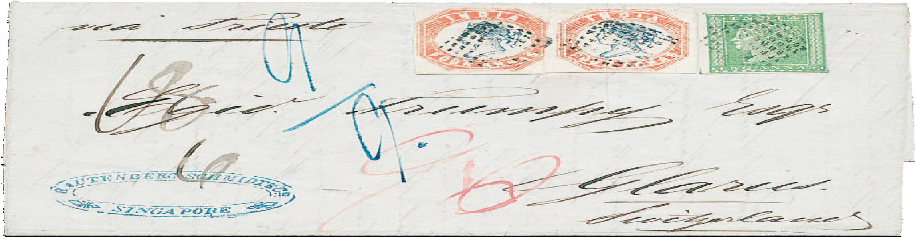

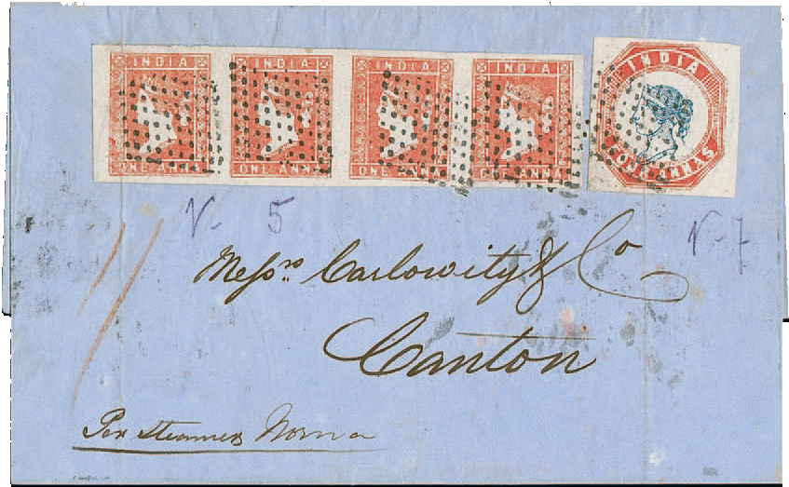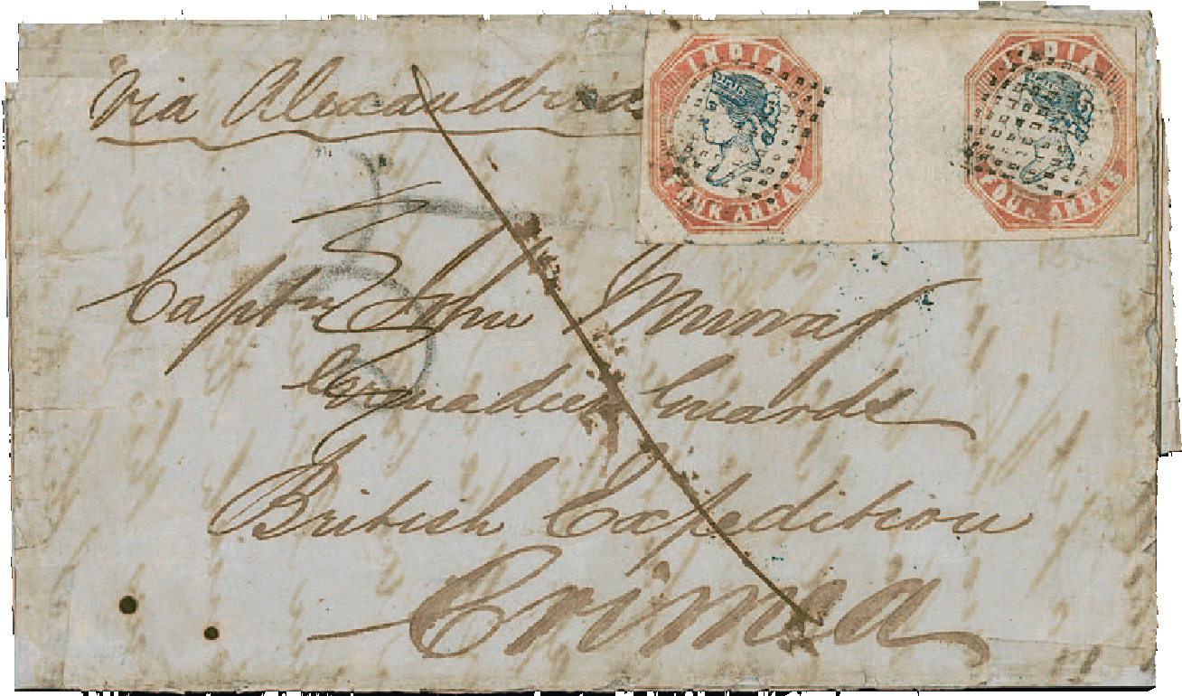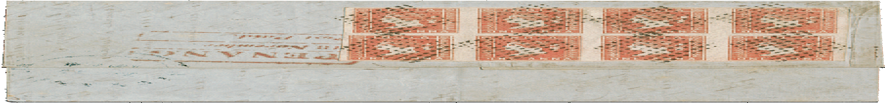
Wednesday, May 10
Travel day to midtown Manhattan in New York City, which is an extraordinarily easy and pleasant journey (2h45m travel time) from Washington, D.C. on the famous Acela Express train. The Acela departs at the superbly restored and historic Union Station, located across the street from the National Postal Museum. Our New York office is a short distance from New York Penn Station.
Air travel is also quick and easy from nearby Ronald Reagan Washington National Airport (DCA).
The Siegel International Team



Charles F. Shreve Director, Siegel International charles
@siegelauctions.com
Andrew Titley
VP, Siegel International andrew @siegelauctions.com
Chris Anderson
International Specialist chris @siegelauctions.com

Dallas (214) 754-5991 or New York (212) 753-6421

21 West 38th Street, 7th Floor, New York, NY 10018

